# ­­Version Control

The version control allows the tracking and change of project requirements to be monitored and recorded. The Version Control contains the Revision History as well as the RACI (Responsible, Accountable, Supports, Consulted and Informed) Chart.

**Revision History**

|  |  |  |  |  |
| --- | --- | --- | --- | --- |
| **Version #** | **Date** | **Authorization** | **Responsibility (Author)** | **Description** |
| **1** | **21 - Oct** | **SI 354 department** | **Marc Dukes        20288379**  **Caley Higgs        19303483**  **James Kapp       19808941**  **Keegan Lester   19318510** | **Final BRD** |

## RACI Chart for This Document

The RACI chart defines the members level of responsibility with regards to change and authorization of procedures and separate domains. Disputes regarding responsibility can be settled rapidly by referring back to the agreed upon RACI Chart.

#### Codes Used in RACI Chart

R (Responsible)

A (Accountable)

S (Supports)

C (Consulted)

I (Informed)

### RACI Chart

|  |  |  |  |  |
| --- | --- | --- | --- | --- |
| Task | Keegan | Marc | James | Caley |
| Obtaining specifications | R | R | R | R |
| Assess competitors | C | R | C | R |
| Managing team | R | S | S | S |
| Designing System | R | R | R | R |
| Testing | C | C | R | C |
| Implementing | A | R | R | A |
| Final Evaluation | C | C | C | C |

**Executive Summary (Marc - Need to add)**

The “Executive Summary” section should be a précis of the entire document. It should summarize, in a page or two, the context for the document (why it was written), the main issues raised within, and the main conclusions of the document. The purpose of the summary is to provide just enough detail for a high-level stakeholder (who may not have time to read the whole thing) and to help any other potential reader ascertain whether it is worth reading the rest of the document.

This is a one-page summary of the document, divided into the following subsections.

**Overview**

This subsection of Executive Summary is a one-paragraph introduction that explains the nature of the project.

**Background**

This subsection of Executive Summary provides details leading up to the project that explain why the project is being considered. Discuss the following where appropriate: marketplace drivers, business drivers, and technology drivers.

**Objectives**

This subsection of Executive Summary details the business objectives addressed by the project.

**Requirements**

This subsection of Executive Summary is a summary of the requirements addressed in this document.

**Proposed Strategy**

This subsection of Executive Summary recommends a strategy for proceeding based on alternatives.

**Project Scope**

The Bank of the Sun online banking service is designed to be used by the public. The CEO, CIO, and an IT department have access to the Backend functionality of the application program. Discussed below is the business areas that are included and excluded in the scope.

**Included in the Scope**

The Bank of the sun online banking service is designed to be functional on all technologies except cell phones. The services available are Account details and a user will be able to transfer money to other accounts.

The user should have access to a help function and they must be able to logon to their account with a username and password with two factor authentications to maximise security. Once logged in a home screen with different icons should display. The icons included should be messages, buy, payment, cards, business, and transfers. Users can see their payment history in their messages. Users can buy electricity, airtime, and lottery tickets. Different card options are available, they are; Savings, Current, and credit accounts. When logging into a business account from your account you are required to login with a unique username and a password that is unique to that business. The logon on procedure should also require a two-factor authentication to ensure security. Users can have more than one account and transfers can be made from one to the other.

From each page users, must be able to switch back to the home page. Users should be able to query for help during working hours.

**Excluded in the Scope**

Excluded from the scope is functionality on cell phones. Users are unable to ask for additional help online and must wait for working hours.

**Constraints**

There are many factors that can limit the success of this project. There are many strict deadlines that are not flexible. The project team must plan their time constructively and work with what they have. The project team is based at the university of Stellenbosch, and so limited programs are available to complete the project.

**Risk Analysis**

The Risk analysis table created below is a list of possible threats to the project. There likelihood of occurrence is indicated as well as a method used to combat the possible threat.

|  |  |  |  |
| --- | --- | --- | --- |
| Risk ID | Description | Likelihood  of Occurrence | Strategy |
| System Breach | A system breach by hackers attempting to access users accounts. | Low | Implementation of two factor authentication. |
| Data Breach | Attempting to access user Information stored in the database. | Low | The use of an API to  keep database information secure and separated from the online website. |
| Bugs | A flaw in a computer  programme which results  in the output of incorrect  results. | High | High level testing and  use of the application  before released to the  market to identify  errors. |
| Multi-login security | Business accounts have the ability to log multiple users into the same account | Low | Implementation of two factor authentication. |
| Multi-account security | Users can log into their business account and personal account on the same details. | High | Complications will  arise when assigning  multiple accounts the  same login in details. |
| SQL injection | Entry into the back end through SQL injection | High | The use of an API for protection |

**Business Case**

The Bank of the Sun realises that its online banking services are not appropriate for banking in 2018, and therefore aims to improve the current system and add to its existing functionality. These additions to the banking system should improve the user experience, while being functional and efficient.

**Issues**

According to a client, one of their major concerns with the current system is the speed of processing various requests. Therefore, improved speed and usability will be an important specification when designing the new system. This agrees with studies which show that there is a significant correlation between Web download speed and the user satisfaction (Jayawardhena & Foley, 2000). Slower websites lead to dissatisfied customers who may look to a different bank to fulfil their expectations. Although Web speed is dependent on many external factors, including factors caused by the user itself, it can be improved by removing unnecessary high-quality images and non-functional elements.

For any bank or financial institution, security is of utmost importance. Just as there are security measures at a physical bank branch (cameras, bullet-proof glass, security guards, etc.), there should be sufficient security measures for the web application. Currently, when a user logs in all they need to provide is their account number and password as identification. This form of security is too basic and can lead to major losses, especially for large corporate companies who may share a common username and password. The reputation of The Bank of the Sun as being a secure bank would also be tarnished, which would in turn discourage current and future clients from investing.

**Proposed Solution**

Having a fast website, while incorporating all the features required by the CEO, will be of the highest priority. These features include, but are not limited to – making transactions, internal and external transfers, view and create statements, and applying for an account. Although some of these services are already provided by the existing online banking website, they will be remodelled and improved, especially in terms of effectiveness and efficiency.

The frontend of the website will be developed using HTML5 (Hypertext Markup Language), with CSS (Cascading Style Sheets) for easy modification and styling. The backend of the website will be developed with JavaScript (in particular the React library) and any other language or means that the development team deems necessary and beneficial to the project. As this project deals with confidential client information (such as bank balances, usernames and passwords, etc.) the team will not have direct access to the bank database but will communicate with it through an Application Programming Interface (API).

Making use of an API is one security measure, but other security measures such as two-factor authentication (2FA) and reCAPTCHA need to be implemented. 2FA provides an extra layer of security by confirming the user identity after login using a Time-Based One-time Password (TOTP) (Speakeasy, 2017). This TOTP is a six-digit code which lasts for 30 seconds and can only be used once (Gohil, 2018). reCAPTCHA is a free service from Google which uses advanced risk analysis techniques to distinguish between humans and bots (Google, 2016). Using both of these security measures will greatly improve the quality of the web app by offering protection from both bots and hackers.

**Justification**

Providing a good internet banking service has advantages for both clients and the stakeholders. A study undertaken by Jayawardhena and Foley (2000) highlight several of these benefits. A major advantage for The Bank of the Sun is cost saving in the long term (Refer to Market Share Benefits for estimated figures). This cost saving is the result of a combination of factors such as a reduction and optimisation of workforce, equipment, resources, space, etc. (Jayawardhena & Foley, 2000, p. 21). Improved services also lead to an increased customer base and existing customer retention. The Bank of the Sun will build a reputation of being an innovative bank which will gain the trust and interest of existing and potential customers. Having a web application can also encourage the development of non-core business such as insurance and stock brokerage (Jayawardhena & Foley, 2000). Important advantages for the client include convenience and efficiency. The client will no longer need to stand in long queues to open a new account or to make transactions.

Two-factor Authentication is a must have for online banking (Gohil, 2018). With more than 65% of users that use the same password everywhere, it is extremely easy for hackers to breach user accounts. The advantage of using 2FA, and in particular Google Authenticator, is that verification codes are generated on your mobile device even when there is no data connectivity. Backup codes can also be printed or downloaded in situations where you may not have access to your cell phone (Gohil, 2018). The advantage of using reCAPTCHA is that it is a free service offered by Google, which is fairly easy to implement and helps to reduce phishing and spam on the website (Google, 2016).

Front-end website development is done, in most cases, using HTML and CSS. Back-end development can be done using a variety of different programming languages. The decision to use JavaScript is based on the fact that it is a powerful, flexible, expressive and accessible language (Brown, 2016, p. xv). Using libraries, such as React, further improve the functionality and power of JavaScript.

**Organisational Impacts**

As a web application currently exists at The Bank of the Sun, and the project is to improve this website, there will not be any major organisational effects. There will be a short-term increase in the number of IT staff employed. All staff will also be trained and familiarised with the new system in order to help clients that come to the physical branch with questions about the application. As this bank is small and is still developing the number of employees will change as the CEO deems necessary during its expansion. The fee system might also be restructured to include the costs of the new online banking features, but this is also up to the discretion of the CEO.

**Project Assumptions**

The following assumptions apply to the web application:

·         Due to privacy and security concerns the database of the bank will not be directly available, but will be accessed through an API

·         Sufficient funding will be provided by The Bank of the Sun to complete the project – this includes planning, development and implementation of the web app; and training of the staff

·         A hardened online banking system designed for production use is NOT required, but only a functional prototype

·         Due to the demographics of the Stellenbosch area (i.e. mostly students), we assume that the target market is interested in online banking and will make use of these new features.

**Market Share Benefits**

According to the FinScope Consumer survey (2016) 77% of South African adults (over 15 years of age) have a bank account, compared to 46% in 2004 (Ramos, 2017). This indicates a remarkable increase in the demand for banks in South Africa, and presents an opportunity for new banks, such as The Bank of the Sun, to fulfil the demand.

Initially developing an improved web application will lead to increased expenses (Hernando & Nieto, 2007). Marketing costs will increase as the bank aims to convert its existing clients to the new system or in order to capture new clients. Staff costs will also increase as existing IT employees or a third party company is required to develop the website. Return on equity (ROE) and return on assets (ROA) are two indicators of profitability. According to the research done by Hernado and Nieto (2007) on banks in Spain, both ROE and ROA will only become significant one and a half years after the implementation of online banking. The overall risk profile, measured using the Pearson Coefficient, will not be significantly affected. If these statistics are consistent with conditions in South Africa, it indicates that improving the banking website will be costly in the short-term, but profitable in the long-term.

The main competitors are those banks that have internet banking, but especially those that have a mobile banking application. According to research done looking at the stakeholder perspective of mobile banking - “banks need to offer mobile banking to compete and provide enhanced customer value – mobiles are the device of choice among many consumers and will drive industry adoption by creating further ‘demand pull’” (Mullan, et al., 2017, p. 1168). This agrees with research which predicts that over 1.75 billion mobile phone users will have used their devices for banking by the end of 2019 (Juniper Research, 2014). There is exceptional customer demand for mobile banking, and therefore this is something that The Bank of the Sun should look to invest in soon. For now, a temporary solution of a responsive web application that is compatible on all mobile devices will be implemented.

**Time table**

The time table below is an important aspect for planning and management of the progress for the task in hand. It displays the relevant dates for the different phases and their due dates.

|  |  |  |
| --- | --- | --- |
| **Phase** | **Start Date** | **Completing Date** |
| Analysis Task  Planning  Requirements  BRD | 30th August 2018 | 25th September 2018 |
| Mock up of HTML | 25th September 2018 | 1st October 2018 |
| Implementation | 1st October 2018 | 22nd October 2018 |

**Business Use Cases**

**Business Use Diagram**

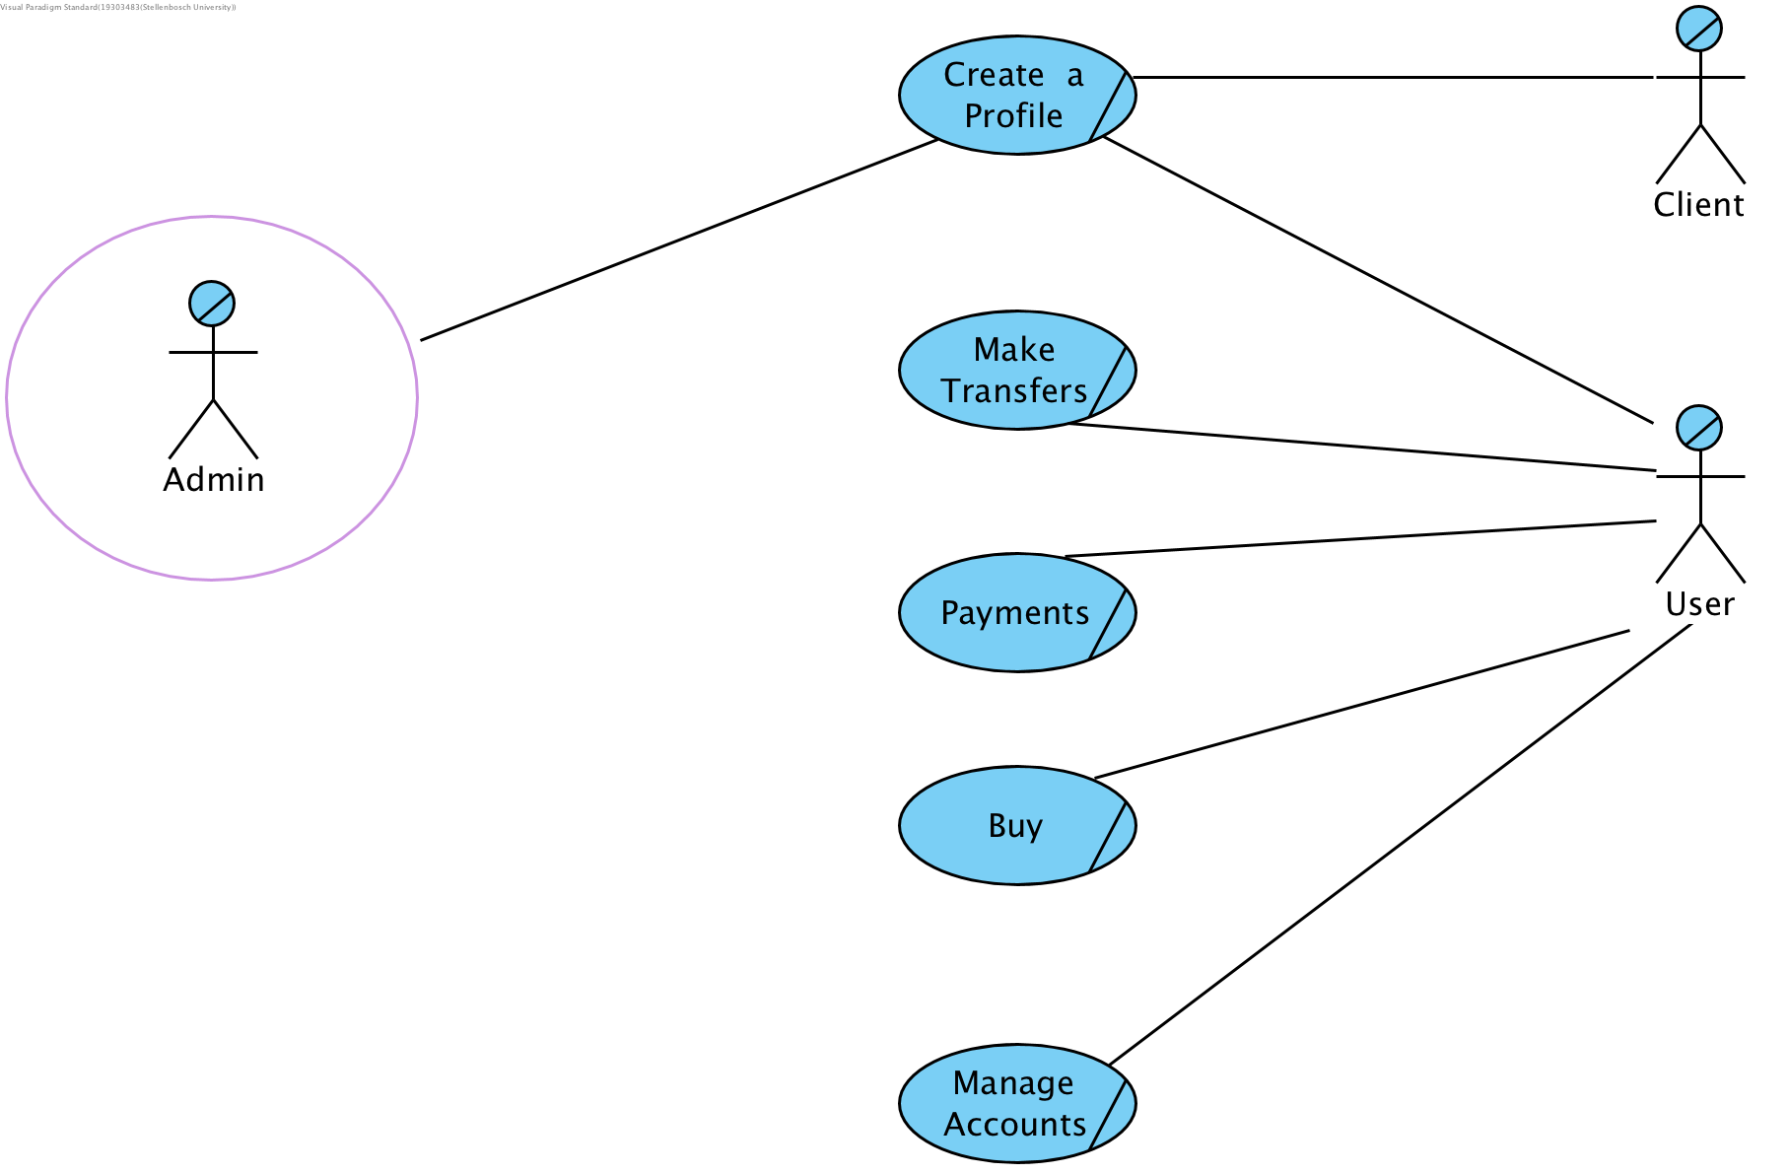

**Business Use Descriptions (Activity Diagrams)**

1. Manage Account - Activity Diagram

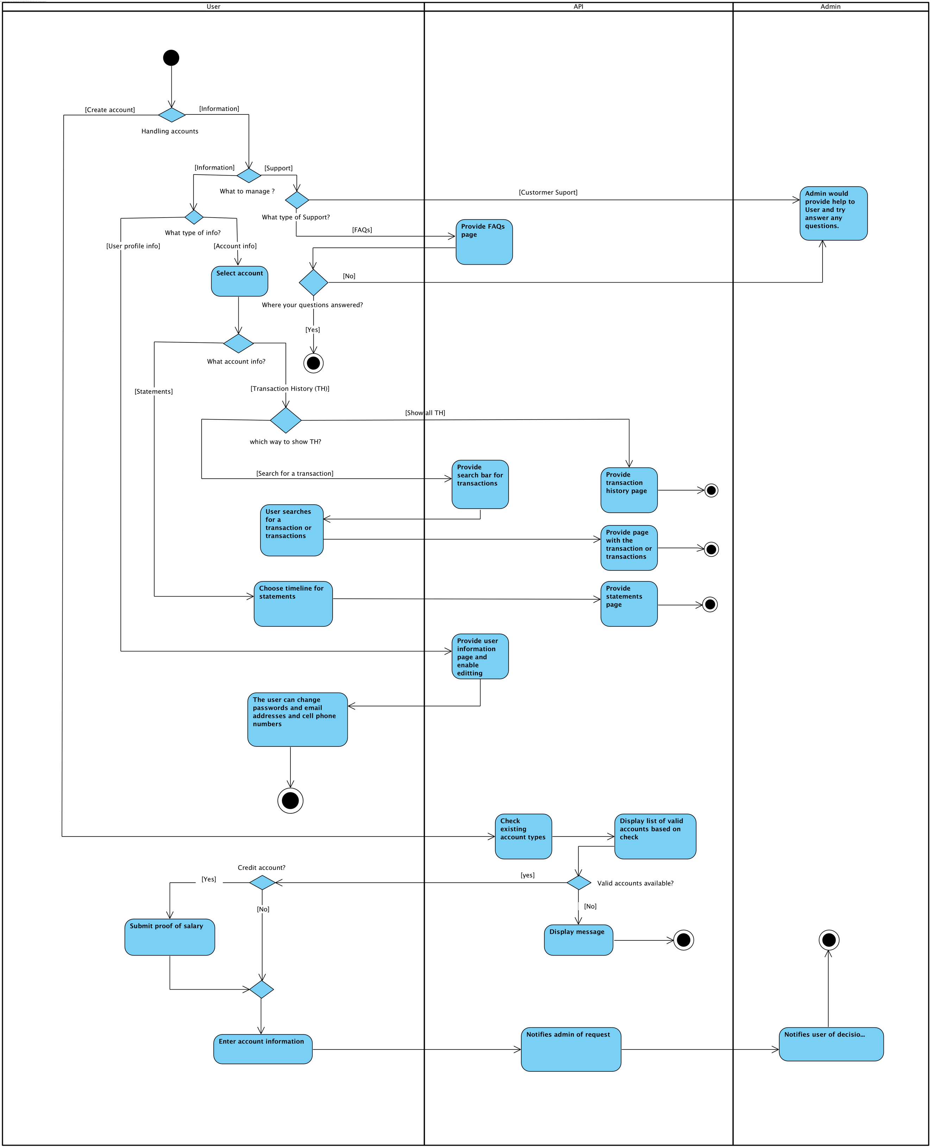

1. Make Payments - Activity Diagram

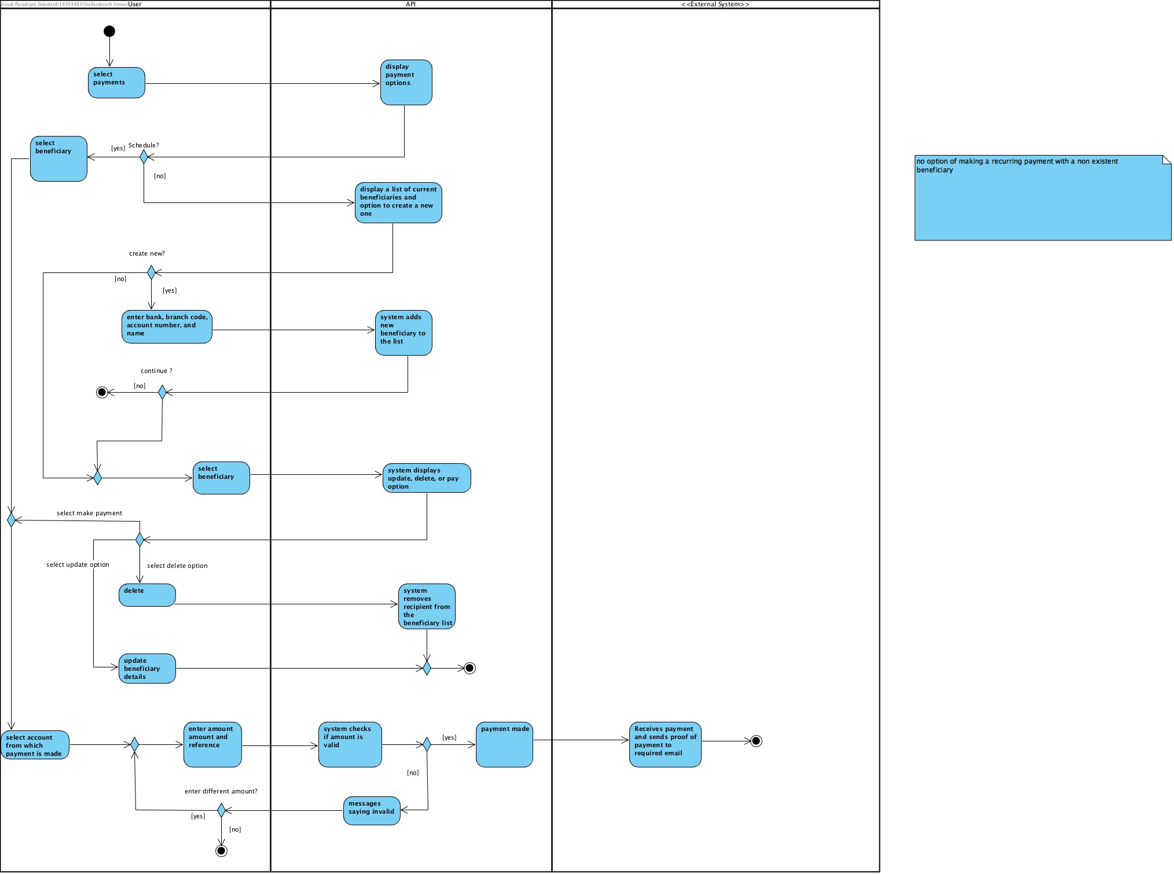

1. Buy - Activity Diagram

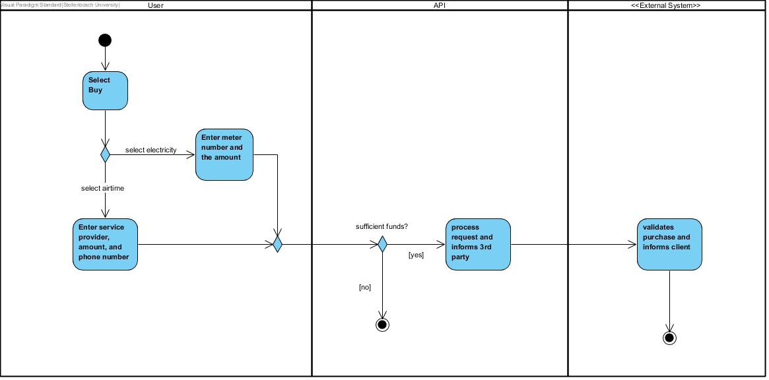

1. Make transfers - Activity Diagram

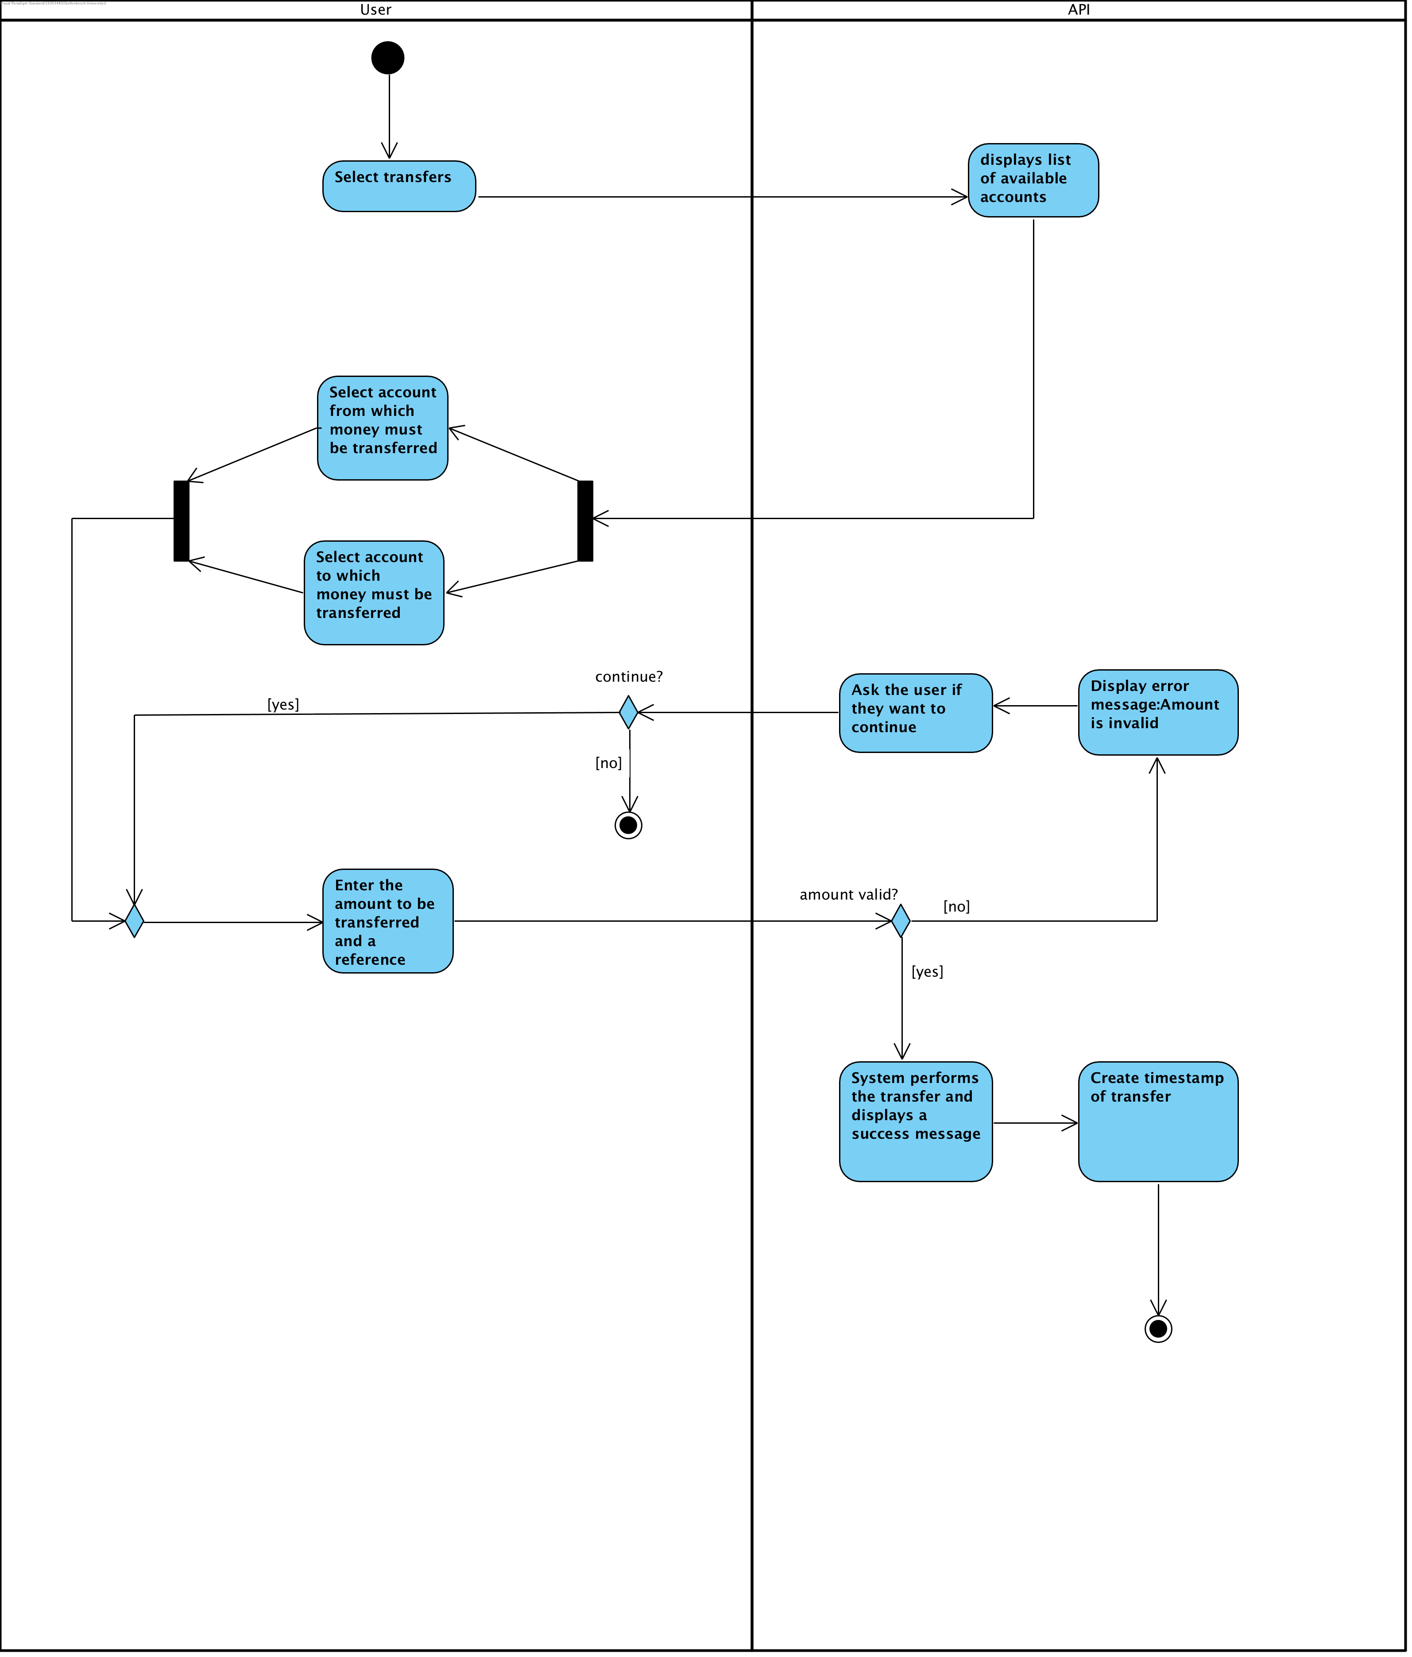

1. Create Profile - Activity Diagram

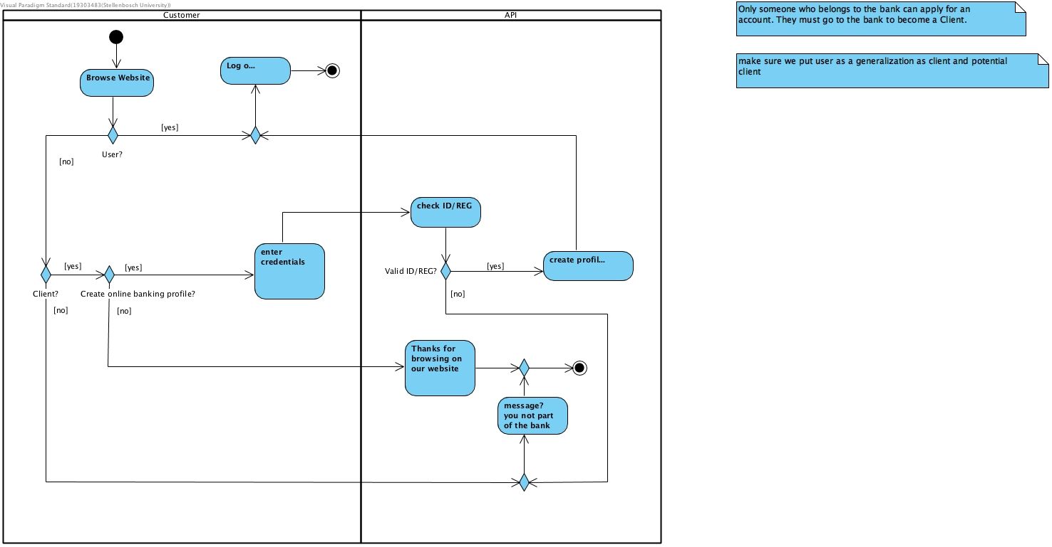

# Actors

## Role Map

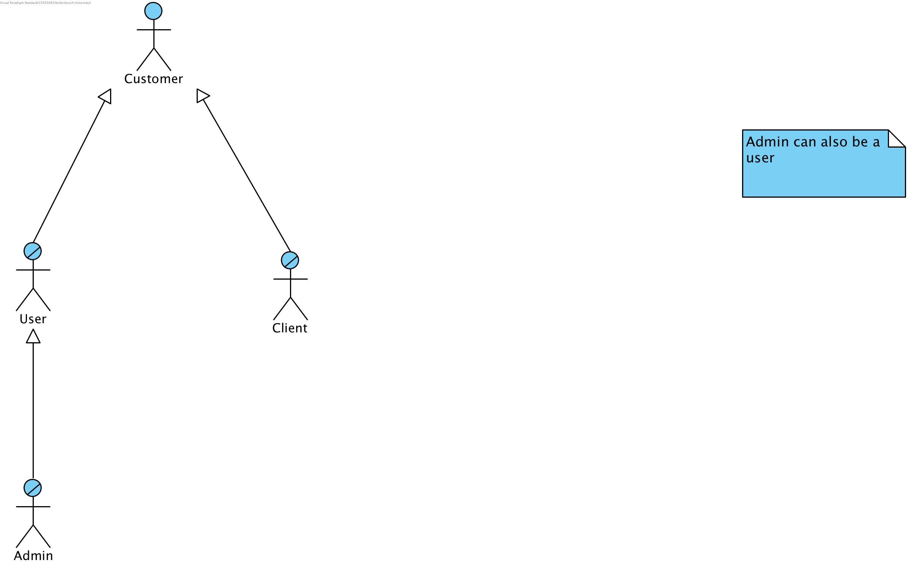

# User Requirements

## Systems Use-Case Diagrams

### **Manage Accounts - SUC [Done]**

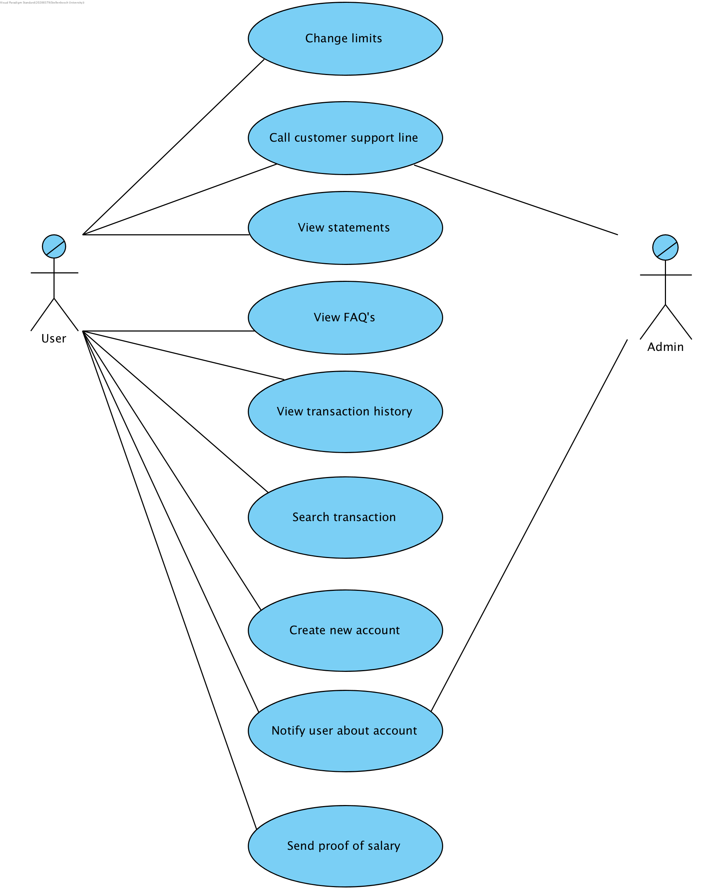

### **Make Payments - SUC**

### **Buy - SUC**

### **Make transfers - SUC**

### **Create profile - SUC**

## System Use-Case Descriptions

### 1.Manage Accounts

### Make Payments

### Buy - SUC

### Make transfers

### Create profile

Basic flow:

1. Browse website
   1. Customer goes to home page of Bank of the Sun
2. Log on
   1. User enters log in details
   2. System validates details
   3. Home page is displayed
3. Create profile
   1. Enter credentials
   2. System validates credentials by checking ID/Reg
   3. Profile is created

**Non Functional Requirements**

**Performance Requirements**

* Stress requirements

BOTS must be able to handle 5000 users at any one point in time

* Response-Time requirements

Transfers must be able to happen within 2 minutes

Other functionality should happen within 1 minute

* Throughout requirements

BOFT must be able to perform 100 transactions per 30 seconds

**Usability Requirements**

An existing client of the bank must be able to able to register for online banking if they are not already registered. Registering must work all online for existing clients and not require them to visit a physical branch.

**Security Requirements**

Users information must be kept secure, therefore users information will be stored within a secure API. The API will ensure that back end information is secure separately from front end script. This will eliminate SQL injection. This will ensure users assets as well as private information is kept secure.

**Volume and Storage Requirements**

The bank is a single branch and situated in a relatively small town. Therefore it will not be handling levels of traffic similar to larger nationwide banks. The bank has planned for high traffic times such as work hours, it also understands that traffic will fluctuate anad has planned for this. There is also a plan in place if there possible expansions and growths into different areas.

**Configuration Requirements**

The online banking application is a web service and will be made available on multiple web browsers. Such as, chrome, safari, firefox.

**Backup/Recovery Requirements**

Users private information will be stored securely on the back of the banks software and will not be accessible by hackers from the front end.

**Scalability Requirements**

The online web application will be used on computers so will not need to be scaled for use on other devices.

This is a possible improvement in the future however. The success of the web application could result in the development of a mobile application.

**Availability Requirements**

The online application will be available all year round. This will allow for users to do banking at their time of convenience.